International Colloquium
"Anthropology of Migration: New Research in Russia"
Saint Petersburg, March 1-2, 2019th

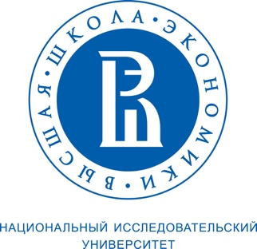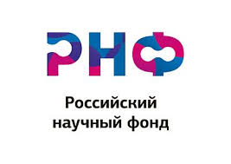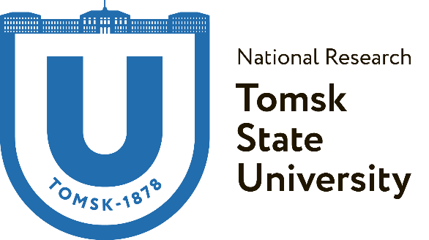

Conference Organizing Committee:
European University at St Petersburg
Russian Science Foundation
Institute for Social Policy of National Research University Higher School of Economics (Moscow)
Laboratory for Social and Anthropological Research, National Research Tomsk State University.

Conference program:

March 1st
13.00-15.00
Securitization and Neoliberal Logic in Russia’s Labour Migration Governance. Bhavna Dave, SOAS, London School of Economics
Access to healthcare services for migrants - savings, chaos of bureaucracy or the way to control? Daniil Kashnitsky, National Research University Higher School of Economics
Network of Georgian restaurants in the Russian metropolis: organization and community. Zakharova Evgenia, Peter the Great Museum of Anthropology and Ethnography (the Kunstkamera)

15.00-15.15 coffee-break
15.15-17.15
“Migrant Schools”: the impact of urban space on school segregation. Ekaterina Demintseva, National Research University Higher School of Economics

Labours of Synchronization: For an Anthropology of Migration Time. Madeleine Reeves, University of Manchester
National-cultural organizations as an element of the ethnic and migrant infrastructure of the Siberian city (on the example of Tomsk and Irkutsk). Victor Dyatlov, Irkutsk State University; Irina Nam, Tomsk State University

17.15-17.30 coffe-break

17.30-19.30
Migrant Illegality and Legal Adaptation in Non-Western Migration Regimes: Central Asian Migrants in Russia and Turkey. Rustam Urinboyev, Lund University and Aleksanteri Institute, University of Helsinki
Does gender have transnationalism? Olga Brednikova, Center for Independent Social Research

Social media and translocal migration between Dagestan and Western Siberia. Ekaterina Kapustina, European University at St Petersburg, Peter the Great Museum of Anthropology and Ethnography (the Kunstkamera)

March 2nd
10.30-13.10
Religious authority and the formation of a local Muslim environment. Dmitry Oparin, Moscow State University, National Research University Higher School of Economics

“In the mountains, in the fields, I ran in search of food, now the opposite ...”: transnational migration through the prism of the history of one Kyrgyz family. Vera Peshkova, Federal Center of the Theoretical and Applied Sociology of the Russian Academy of Sciences

Migrant localities of Irkutsk in the daily life of the city. Konstantin Grigorichev, Irkutsk State University, Dmitry Timoshkin, Irkutsk State University
Uzbekistan’s special path: protectionist economy, transnational migration and traditionalism. Sergei Abashin, European University at St Petersburg

13.10-14.00 lunch
14.00-16.40
“I prefer to work for myself”: segments of entrepreneurial activity of labor migrants from the republics of Central Asia in the Siberian city (the example of Tomsk).
Seil Dzhanyzakova, Tomsk State University
Notes "Non-Muslim" on the importance of Islam for migrants in the university city.
Fedor Smetanin, Tomsk State University
Migrants in the city: “ethnic” market as a mechanism for transforming the urban environment (the example of the city of Irkutsk). Diana Bryazgina, Tomsk State University

Reflections on the point of no return: participating observation as an “antimethod” in the study of the migrant community. Anton Sadyrin, Tomsk State University

Russian Scientific Foundation: projects № 14-18-02149-П “Transnational and translocal aspects of migration in modern Russia”; №18-18-00293 “The use and creation of urban infrastructures by migrants in Siberian regional centres”

